TECHNICAL PROJECT REPORT

# Title of Invention / Project:

TAP SWITCH GAME

# Team Members / Inventors:

|  |  |  |  |  |  |
| --- | --- | --- | --- | --- | --- |
| **S. No.** | **Name** | **Department** | **Designation** | **Mobile** | **E-Mail** |
| 1. | UTKARSH GANGWAR | BD-1 | Student | 8791707291 | [Utkarshketh.gangwarrox@gmail.com](mailto:Utkarshketh.gangwarrox@gmail.com) |
| 2. | SHIV VERMA | BD-1 | Student | 8637382212 | [Vermashiv336@gmail.com](mailto:Vermashiv336@gmail.com) |
| 3. | ANKIT SINGH | BD-1 | Student | 7987222276 | [ankit137singh@gmail.com](mailto:ankit137singh@gmail.com) |
| 4. | NAVEEN | BD-1 | Student | 7889181760 | [Naveenmadi66@gmail.com](mailto:Naveenmadi66@gmail.com) |
| 5. | Khushal Thakur | ECE | Mentor | 9646030764 | [khushal.thakur@cumail.in](mailto:khushal.thakur@cumail.in) |
| 6. | Anshul Sharma | ECE | Mentor | 9478697475 | [anshulsharma.ece@cumail.in](mailto:anshulsharma.ece@cumail.in) |
| 7. | Kiran Jot Singh | ECE | Mentor | 9463909689 | [kiranjotsingh.ece@cumal.in](mailto:kiranjotsingh.ece@cumal.in) |
| 8. | Divneet Singh Kapoor | ECE | Mentor | 9878422653 | [divneet.ece@cumail.in](mailto:divneet.ece@cumail.in) |

SECTION-1(IPR Related)

BRIEF ABSTRACT:

This is an arduino based tap switch game . This is an multiplayer game in which two players can play at a time and compete against each other . The person needs to tap the switch as fast as possible 100 times and the person to tap switch first 100th time wins the game. This setup consist of 3 Arduino UNO’s which are interconnected with each other . Each Arduino is connected to a separate breadboard in which 4 led’s are embedded along with suitable resistances and a button switch . Led’s are programmed in such a way that it blinks for the first 20 times the switch is pressed and then it starts glowing constantly after each 20th time next led starts blinking and follows the same pattern . After the 100th time all led’s starts blinking and indicates the winner. The final breadboard is connected to a LCD and a Arduino Uno which declares the winner name on screen . The first two arduinos are programmed in such a way that as soon as the the switch is pressed the 100th time it directs the signal to the final Arduino the final arduino interprets the signal and generates a response accordingly on the LCD.

Problem Project Is Solving :-------

This project is mainly for entertainment purpose . Anyone can play this game and can enjoy . Anyone can compete against any other person and can challenge for this game and can have a good time . This game can act as a mood elevator and can divert your mind from stress causing problems for some time . This reduces stress upto some extent . This game can be played by people in their free time and basically it’s an challenge game in which two competitors can challenge each other for a round of this tap switch game to check whose faster among themselves . It promotes healthy competition.

**HOW ARE WE SOLVING THE PROBLEM?**

Stress is an common problem these days we cannot eliminate the stress causing problems but we can provide an escape to your mind from those problems for some time and can make you feel better and will surely elevate your mood . You can also use your aggression in a healthy way to win this game by pressing switch faster than your opponent.

**ADDITIONAL MODIFICATIONS THAT CAN CATER TO IMPROVED SOLUTION:------**

Certainly some other modifications can be done with this project . For the starting the setup can be optimized in terms of its size so that it is easily portable and is convenient to carry anywhere . Different patterns can be implemented on the leds to make it look even better and appealing to eyes . The number of leds can also be increased in this setup . Leds can also be used on the final breadbroard along with displaying the name of winner on LCD and additional led can also blinks on the final breadboard . At last and most importantly this setup could be done on printed circuit boards to optimize it and it can also be given outer appearance accordingly.

# Existing state-of-the-art and Drawbacks in existing state-of-the-art

|  |  |  |
| --- | --- | --- |
| S.no | Existing State Of Art | Drawbacks In Existing State Of Art |
| 1. | Arduino game to testyour reflexes: This is a game that has a light bouncing back and forth along a row of LEDs. Push the button when it is in the middle to level up. Work your way through twenty levels to win! | # This is not an multiplayer game which means only a single player can play at a time.  # It’s an monotonous game which can get boring at times also as there no one else to compete with. |

Novel/Additional modifications that you can propose to improve upon drawbacks:

1. It can be converted into an multiplayer game to make it more interesting to play.
2. To make it a bit more challenging we can increase the speed of blinking leds with every increase in level hence it would be more intresting .

Advantages:

1-Its an multiplayer game so more than one person can play at a time .

2-Its an challenge game unlike other monotonus games which promotes competion among the participants.

3-Works as an mood elevator since its an game for entertainment and reduces stress .

4-This game can be used to kill time by challenging others to check who is faster.

BLOCK DIAGRAM----------

LCD

ARDUINO

2

ARDUINO

3

ARDUINO

1

**SECTION-2(REAL PROJECT)**

**MATERIALS:**

|  |  |
| --- | --- |
| **MATERIALS** | **COST**  (in Rs.) |
| **3 Arduino Uno** | **450*3= 1350** |
| **3 BREADBOARDS** | **50*3=150** |
| **50 JUMPER WIRES** | **3*50=150** |
| **RESISTANCE** | **20** |
| **10K Potentiometer** | **50** |
| **16*2 LCD** | **250** |
| **USB HUB** | **150** |
| **SWITCH** | **20** |
| **3 ARDUINO USB CABLES** | **20*3=60** |
| **LEDS** | **20** |
| **TOTAL** | **2220** |

**CIRCUIT DIAGRAM:**

1. **Connection of 3 ARDUINOS UNOS with each other.**

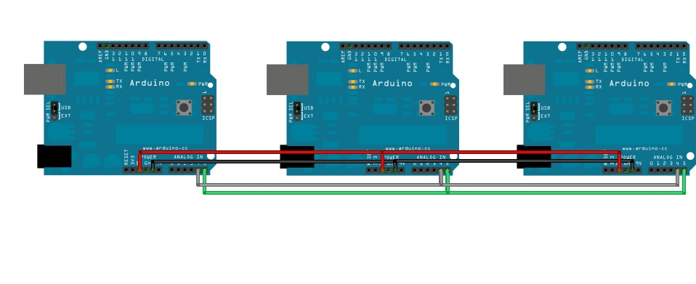

1. **Connecting LCD to MASTER Arduino**

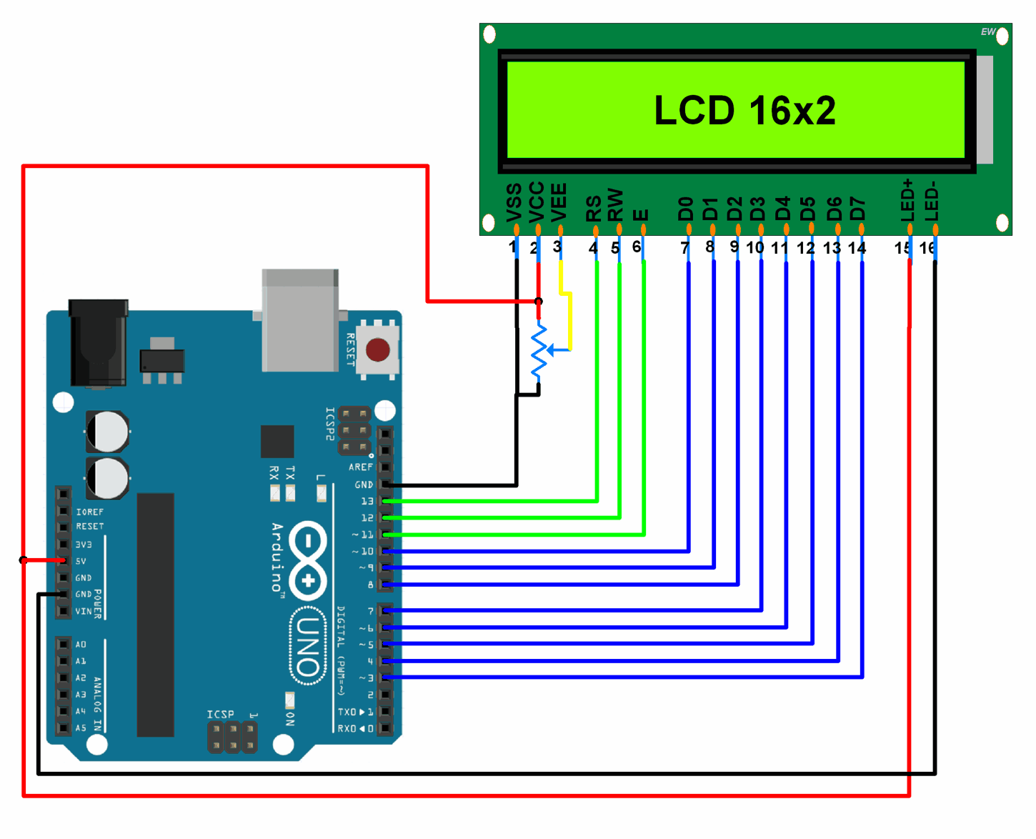

**3.Connecting slave Arduino to respective breadboards and LEDs**

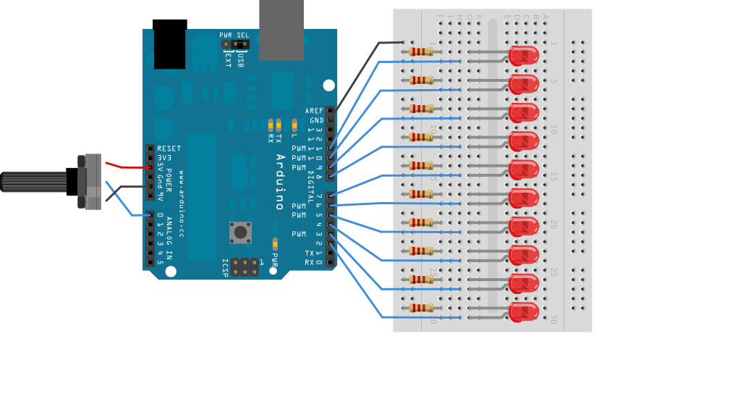

**STEPS OF CIRCUIT COMPLETION:**

It was not an easy task to complete our project as it consisted of complexities like collecting materials and arranging them as per the setup . We had to go through a hell lot of steps for our Circuit Completion:

1. Gathering all the material required for the circuit which included visiting electronics shop again and again as per the availability of different devices.

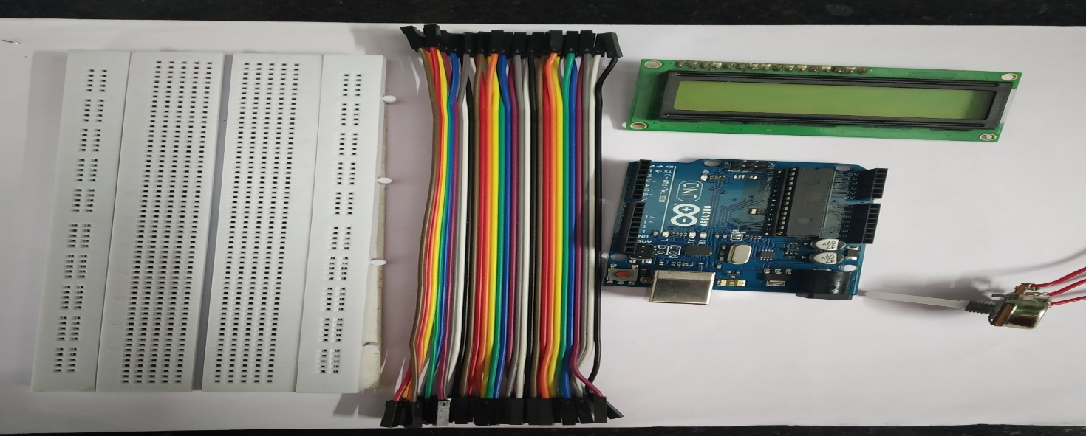

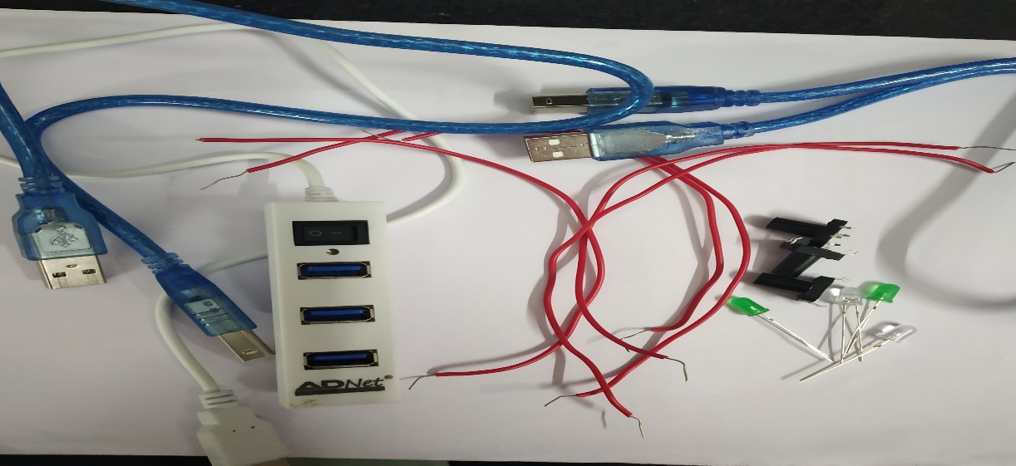

2. After learning about how to make connections, circuit formation started with connecting Arduino with different devices and breadboard.

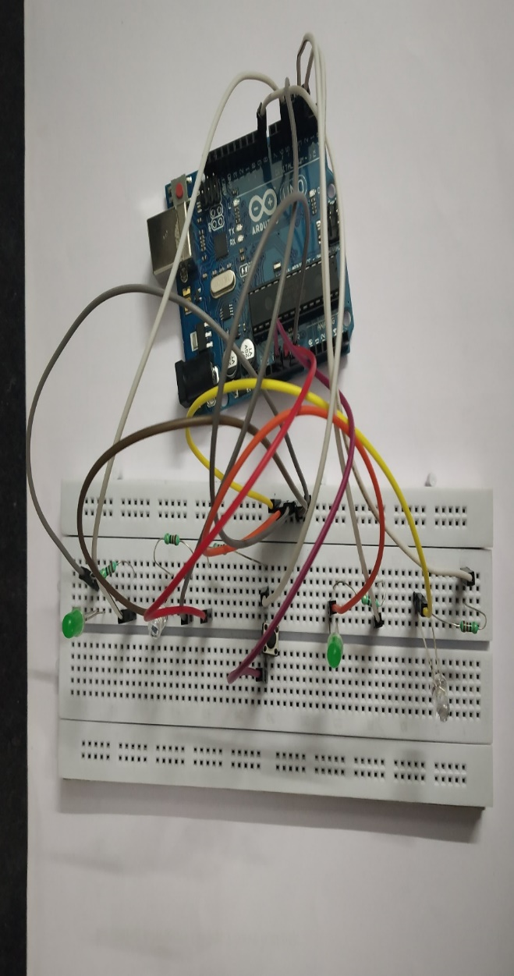

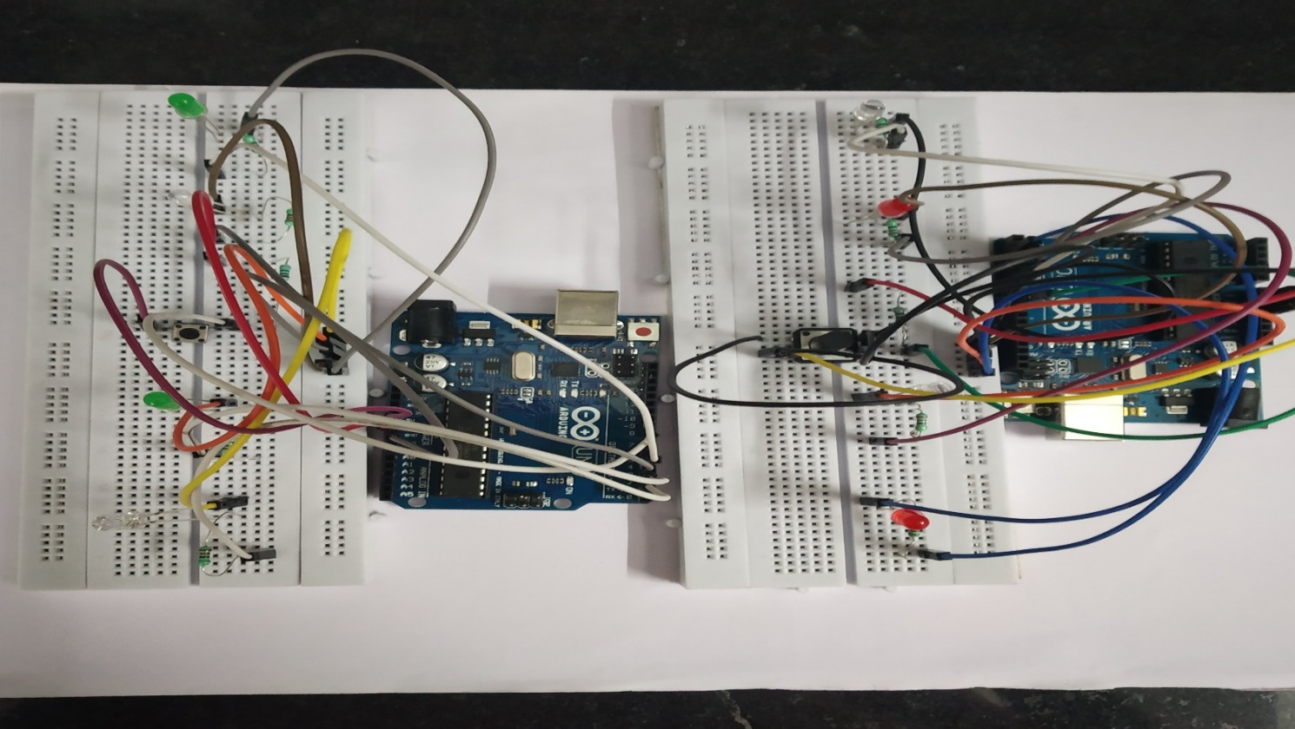

3. Successful connection of LCD with Master Arduino, Potentiometer

**4. Final assembly of all the components of game setup**

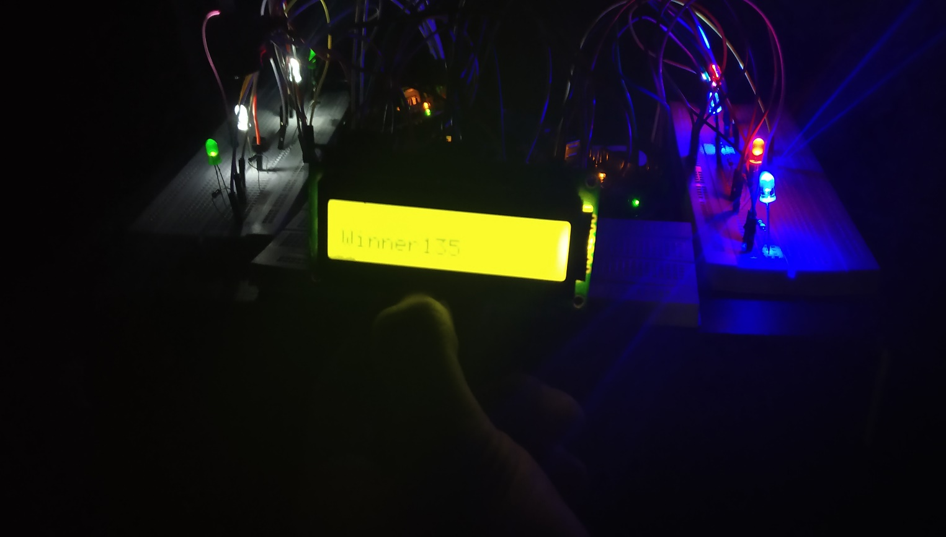

**PROGRAM CODE**

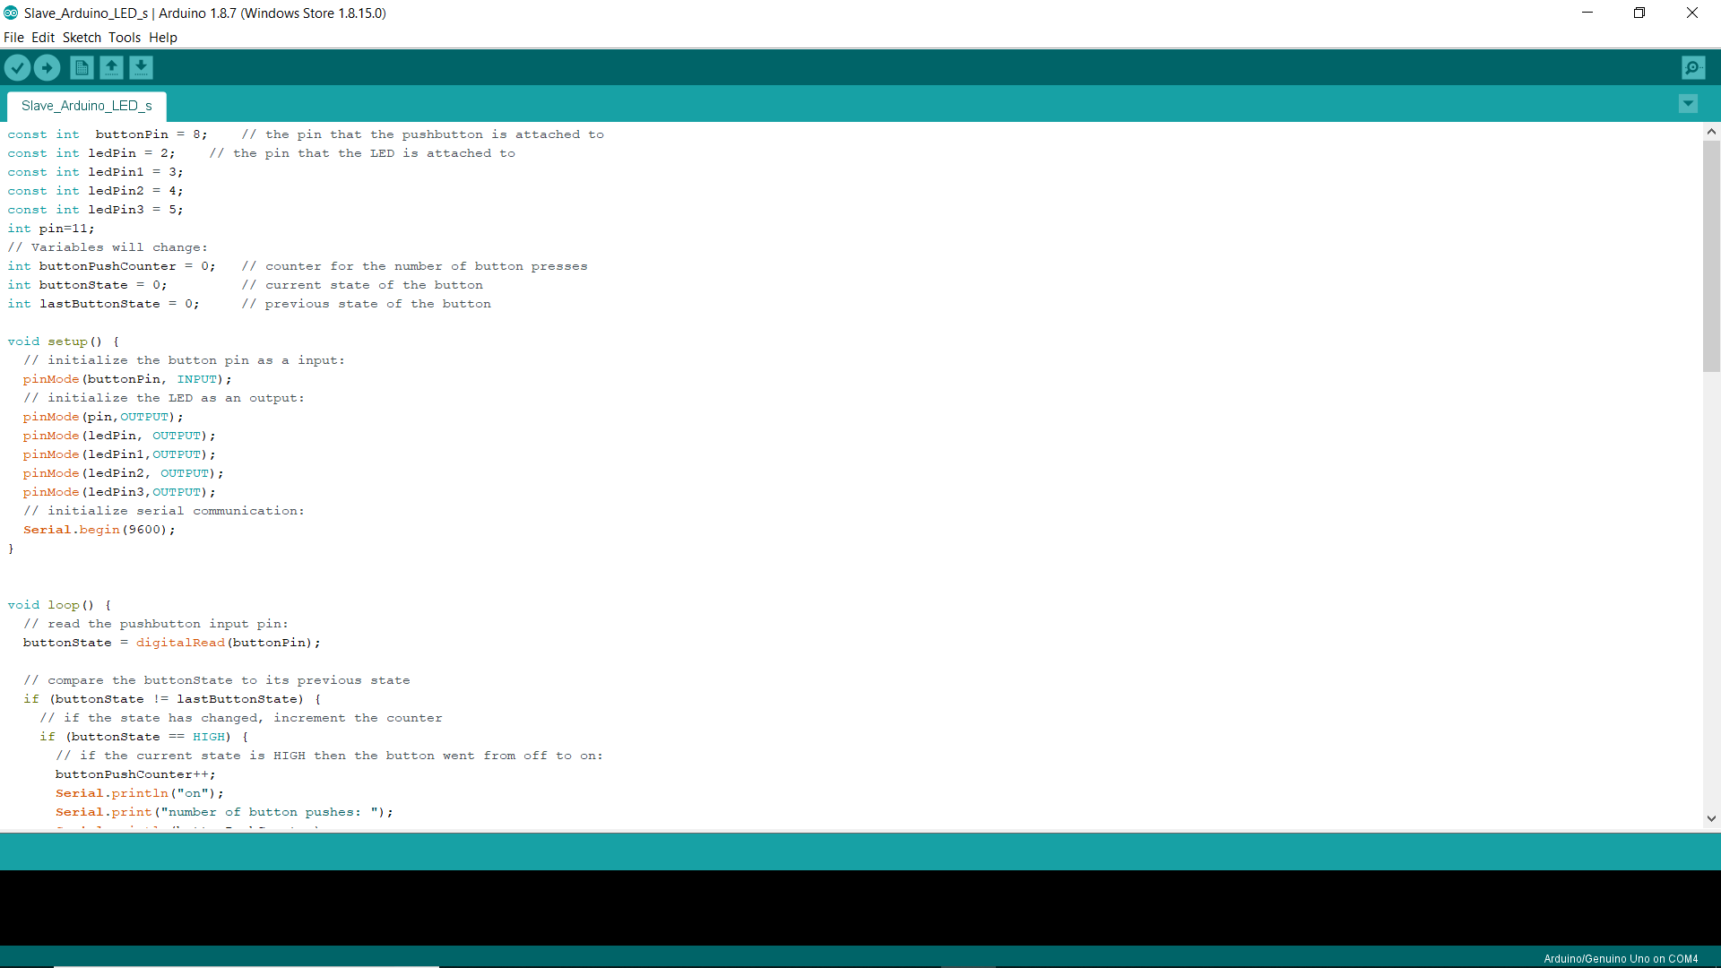

<https://github.com/utkarshgangwar23/TAP-SWITCH-GAME>